44-560 Advanced Topics in Database Systems
From the Operational Model to the Dimensional Model

The Sales Database: An operational model

An ER model for an operational database is shown below.

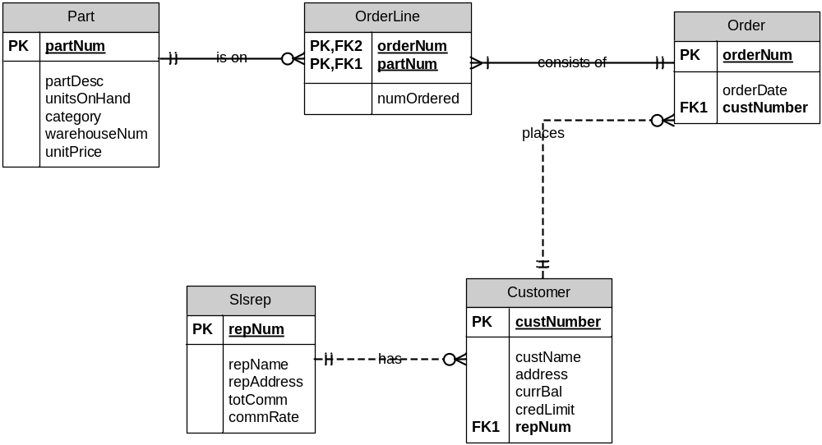

Current data stored in the tables is shown here.

customer
custNumber | custName | address | currBal | credLimit | repNum
124 | Sally Adams | 481 Oak, Lansing, MI | $418.75 | $500.00 | 3
311 | Don Charles | 48 College, Ira, MI | $200.10 | $300.00 | 12
522 | Mary Nelson | 108 Pine, Ada, MI | $49.50 | $800.00 | 12

parts
partNum | partDesc | category | unitsOnHand | warehouseNum | unitPrice
ax12 | iron | appliance | 104 | 3 | $20.00
az52 | skates | sporting | 20 | 2 | $50.00
ba74 | baseball | sporting | 40 | 1 | $10.00
bt04 | stove | appliance | 11 | 2 | $1,000.00
bz66 | washer | appliance | 52 | 3 | $800.00
ca14 | skillet | houseware | 2 | 3 | $10.00
cb03 | bike | sporting | 44 | 1 | $200.00
cx11 | mixer | houseware | 112 | 3 | $70.00
cz81 | weights | sporting | 208 | 2 | $500.00

slsrep
repNum | repName | repAddress | totComm | commRate
3 | Mary Jones | 123 Mina, Grant, MI | $2,150.00 | 0.05
6 | William Smith | 102 Raymond, Ada, MI | $4,912.50 | 0.07
12 | Sam Brown | 41 Harper, Ada, MI | $2,150.00 | 0.05

orderline
orders
orderNum | orderDate | custNum
12489 | 9/2/1994 | 124
12491 | 9/2/1994 | 311
12498 | 9/5/1994 | 522
12500 | 9/5/1994 | 124
12504 | 9/5/1994 | 522

orderNum | partNum | numOrdered
12489 | ax12 | 1
12489 | bt04 | 1
12489 | bz66 | 1
12489 | cb03 | 2
12489 | cx11 | 1
12489 | cz81 | 1
12491 | bt04 | 1
12491 | bz66 | 1
12498 | az52 | 2
12498 | ba74 | 2
12500 | bt04 | 1
12504 | cz81 | 1

Requirements for the Data Warehouse
We wish to design a data warehouse using the data from this operational database.
- The process to be modeled is Customer Sales.
- The grain is daily sales.
- Dimensions will be determined by you.
- The only facts to be stored are amount, representing daily sales total amount, and quantity, representing daily sales total quantity.
We want to be able to answer questions such as:
- How many of part number ax12 were sold on September 2, 1994?
- How many of part number ax12 did Customer 124 purchase last year?
- How much did Customer 124 spend last year?
- What was the average amount spent per customer per day during the month of September, 1994?
- What was the average quantity sold of part ax12 per day during the month of September, 1994?
- What was the average daily sales during the third quarter of 1994?
- How many appliance items were sold during the third quarter of 1994?
- What was the amount of revenue generated by all customers in zip code 64468 during the month of September 1994?
We do not care about answering questions such as the ones below:
- What was the average amount of each order placed during 1994? In fact, we don’t care about any questions related to specific orders.
- How much did salesrep 3 make during 1994? In fact, we don’t care about any questions about sales reps.
- What was the average credit limit for all customers on September 2, 1994? In fact, we don’t care about any questions about credit limits or balances.
- We are not interested in inventory questions – such as which warehouse parts were stored in, or how many units on hand were available during a given time period.
We do not want to store unnecessary data in the data warehouse. In particular, note that specific data about orders and orderline information, as well as salesrep information, is not necessary.
Data must be aggregated as necessary from the operational database before entering it into the data warehouse.

Your Task
Design the star schema dimensional model for a data warehouse to satisfy the above requirements. Do not use any snowflaking. Dimension tables must use surrogate keys. Clearly label primary and foreign keys.

